PL/SQL

2.3:

DECLARE

cursor cur_name IS

select staff_code,staff_name,staff_sal from staff_masters where dept_code=&n order by dept_code;

v_sal number(7,2);

v_code number(10);

v_name varchar2(20);

BEGIN

OPEN cur_name;

LOOP

FETCH cur_name

INTO v_code,v_name,v_sal;

EXIT

WHEN cur_name%NOTFOUND;

dbms_output.put_line(v_code ||´ ´||v_name||´ ´|| v_sal);

END LOOP;

CLOSE cur_name;

END;

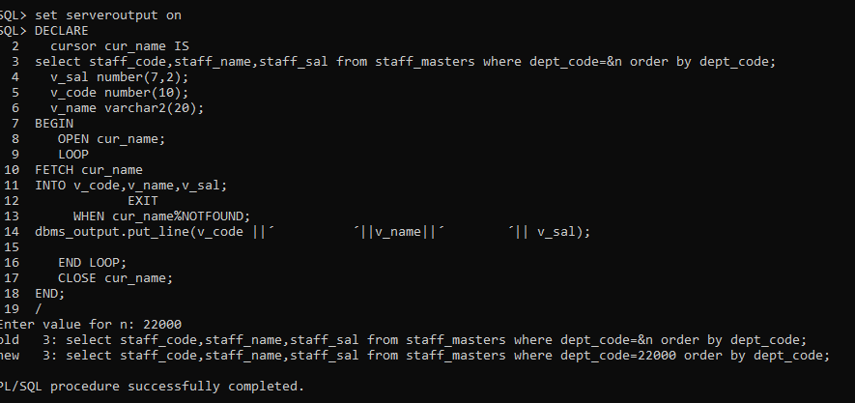

2.4:

DECLARE

cursor cur_name2 IS

select staff_name,staff_sal from staff_masters;

v_sal number(10,2);

v_code number(10);

v_name varchar2(20);

BEGIN

OPEN cur_name2;

LOOP

UPDATE staff_masters set staff_sal=staff_sal+30*(staff_sal/100);

FETCH cur_name2

INTO v_name,v_sal;

EXIT

WHEN cur_name2%NOTFOUND;

dbms_output.put_line(v_name||´ ´|| v_sal);

END LOOP;

CLOSE cur_name2;

END;

/

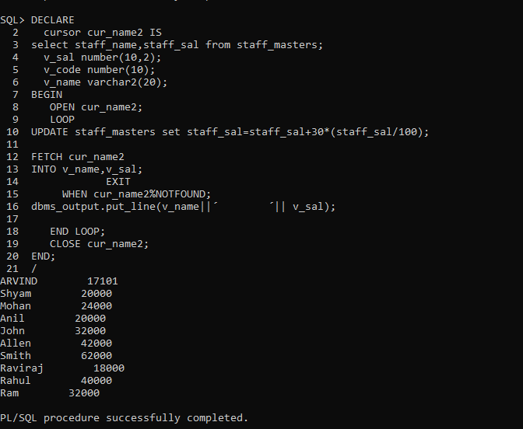

2.5:

declare

cursor cur_name IS

select * from student_masters order by student_code;

cursor vk(par_dept varchar2) IS

select subject1,subject2,subject3 from student_marks where student_code=par_dept order by student_code;

r_code student_masters%rowtype;

v_name student_marks.subject1%type;

v_code student_marks.subject2%type;

v_code1 student_marks.subject3%type;

v_total number(10,2);

v_perc number(10,2);

v_grade varchar2(10);

BEGIN

dbms_output.put_line( ´code ´||´ name ´||´ subj1´||´ sub2´||´ sub3´||´ Total´||´ Percentage´ ||´grade´);

OPEN cur_name;

LOOP

FETCH cur_name

INTO r_code;

EXIT

WHEN cur_name%NOTFOUND;

OPEN vk(r_code.student_code);

LOOP

FETCH vk INTO v_name,v_code,v_code1;

EXIT

WHEN vk%NOTFOUND;

v_total:=v_name+v_code+v_code1;

v_perc:=(v_total/3);

IF v_perc >=80 THEN

v_grade:=´A´;

ELSIF v_perc >70 and v_perc <=80 THEN

v_grade:=´B´;

ELSIF v_perc >60 and v_perc <=70 THEN

v_grade:=´C´;

ELSE

v_grade:=´D´;

END IF;

dbms_output.put_line(r_code.student_code||´ ´||r_code.student_name||´ ´||v_name||´ ´||v_code||´ ´||v_code1||´ ´||v_total||´ ´||v_perc||´ ´||v_grade);

END LOOP;

CLOSE vk;

END LOOP;

CLOSE cur_name;

END;

/

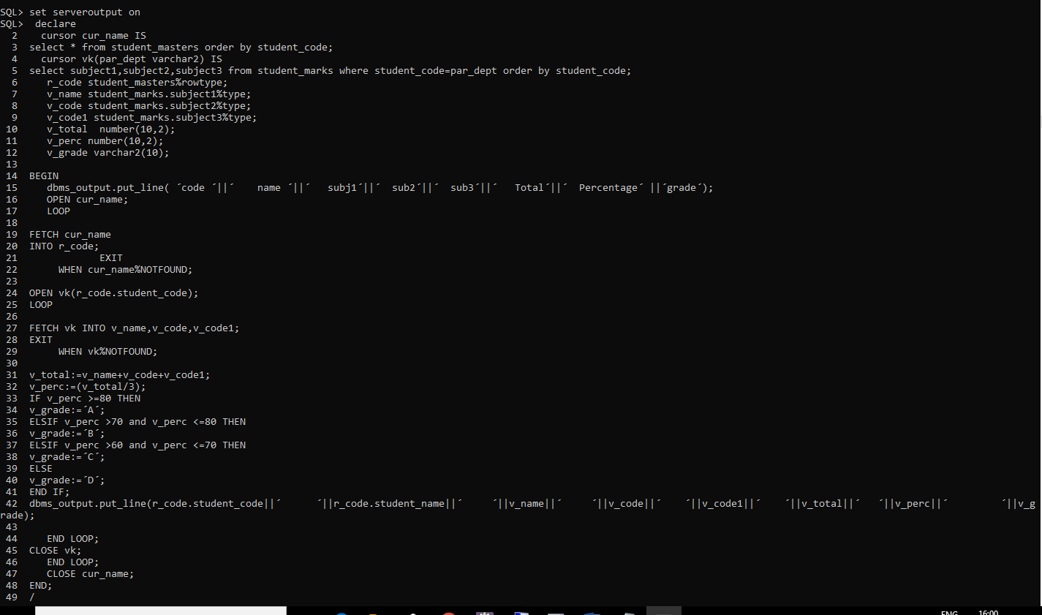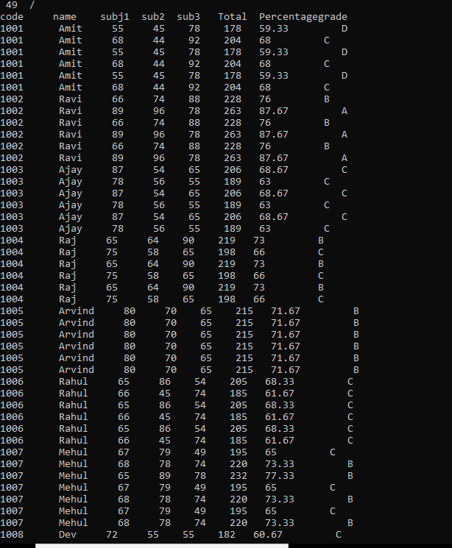

2.6:

DECLARE

cursor prashanth IS

select * from department_masters order by dept_code;

cursor prash(par_dept varchar2) IS

select * from staff_masters where dept_code=par_dept and dept_code=&n order by staff_name;

r_code department_masters%rowtype;

v_code staff_masters%rowtype;

BEGIN

dbms_output.put_line( ´deptcode ´||´ deptname ´||´ staffcode´ ||´ staffname´);

OPEN prashanth;

LOOP

FETCH prashanth

INTO r_code;

EXIT

WHEN prashanth%NOTFOUND;

OPEN prash(r_code.dept_code);

LOOP

FETCH prash INTO v_code;

EXIT

WHEN prash%NOTFOUND;

dbms_output.put_line(r_code.dept_code||´ ´||r_code.dept_name||´ ´||v_code.staff_code||´ ´||v_code.staff_name);

END LOOP;

CLOSE prash;

END LOOP;

CLOSE prashanth;

END;

/

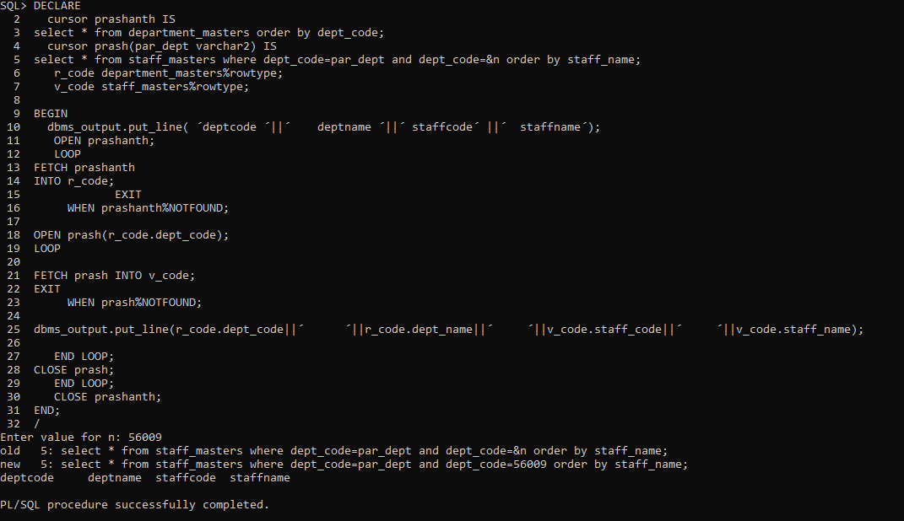

4.1:

DECLARE

cursor cur_name3 IS

select * from department_masters order by dept_code;

cursor vk3(par_dept varchar2) IS

select max(staff_sal) from staff_masters where dept_code=par_dept;

r_code department_masters%rowtype;

v_code number(10,2);

BEGIN

dbms_output.put_line( ´deptcode ´||´ maxsal ´);

OPEN cur_name3;

LOOP

FETCH cur_name3

INTO r_code;

EXIT

WHEN cur_name3%NOTFOUND;

OPEN vk3(r_code.dept_code);

LOOP

FETCH vk3 INTO v_code;

EXIT

WHEN vk3%NOTFOUND;

dbms_output.put_line(r_code.dept_code||´ ´||v_code);

END LOOP;

CLOSE vk3;

END LOOP;

CLOSE cur_name3;

END;

/

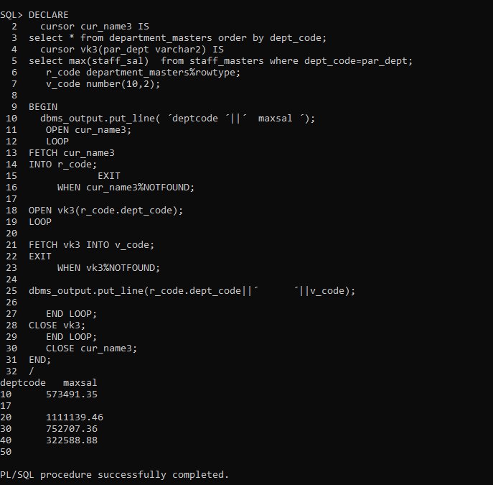

4.3:

create or replace procedure upper_procedure(staff_c in number,staff_n out varchar2)is

2 upper_name varchar2(15);

3 missing_name exception;

4 begin

5 select staff_name into upper_name from staff_masters where staff_code=staff_n;

6 update staff_masters set staff_name=upper(upper_name);

7 if upper_name is null then

8 raise missing_name;

9 end if;

10 exception

11 when missing_name then

12 dbms_output.put_line(´empty´);

13 end upper_procedure;

14 /

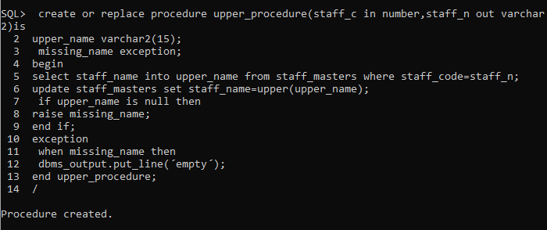

SQL> set serveroutput on;

SQL> declare

2 cursor cur_sal is select max(staff_sal) from staff_masters where dept_code=50;

3 var1 number;

4 begin

5 open cur_sal;

6 fetch cur_sal into var1;

7 dbms_output.put_line(var1);

8 close cur_sal;

9 end;

10 /

4.7:

create or replace procedure proc_vk522(staf_code in number) is

staff_master_back staff_masters%rowtype;

new_sal number;

exp number;

begin

select staff_sal,(sysdate-hiredate) into new_sal,exp from staff_masters where staff_code=staf_code;

if exp>2 and exp<5 then

update staff_masters set staff_sal=0.2*new_sal+new_sal;

else

update staff_masters set staff_sal=0.25*new_sal+new_sal;

end if;

dbms_output.put_line(new_sal);

end;

/

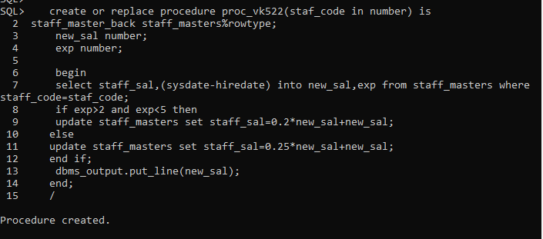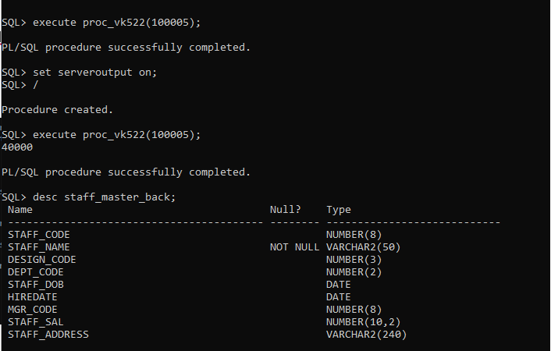

4.8:

create or replace procedure proc_vk(bcode in number,stucode out number,stuname out varchar2,publ_issue_date out date,exp_return_date out date) is

begin

select s.student_code,s.student_name,b.book_issue_date,b.book_expected_return_date into stucode,stuname,publ_issue_date,exp_return_date

from student_masters s,book_transactions b

where b.student_code=s.student_code;

end proc_vk;

/

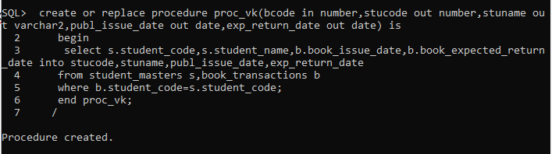

4.10:

reate or replace procedure book_proc(bcode in number,scode in number,stcode in number) is

begin

if(to_char(sysdate,´day´)=´saturday´ or to_char(sysdate,´day´)=´sunday´) then

insert into books1 values(bcode,scode,stcode,sysdate,sysdate+12,sysdate);

else

insert into books1 values(bcode,scode,stcode,sysdate,sysdate+10,sysdate);

end if;

end;

/

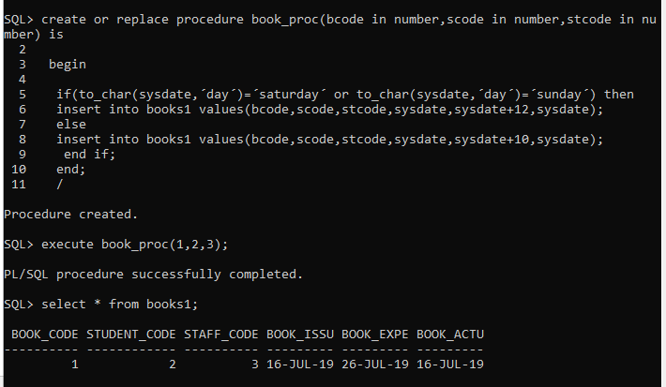

FUNCTIONS:

4.2) create or replace function age(dob in date) return number is agein number;

2 begin

3 agein:=round((sysdate-dob)/365);

4 return(agein);

5 end;

6 /

select age(´27-sep-1998´) from dual;

